CROATIAN OPEN CHAMPIONSHIP – SNIPE 2016.

SAILING INSTRUCTIONS

ORGANIZING AUTHORITY
JK «Split» Lučica 4;
E-mail: jk.split@gmail.com;
www.jk-split.hr

- SCHEDULE OF EVENTS
Date | Time
18.08. | 17:00 – 19:00 | Registration
19.08. | 09:00 – 10:00 | Registration
 | 13:00 | Warning signal
20.08. | 13:00 | Warning Signal
21.08. | 13:00 | Warning signal
 | After last race | Prize giving ceremony

2.RULES
The regatta will be governed by the rules as defined in the
ISAF Racing Rules of Sailing 2013- 2016 (RRS)

3.ELEGIBILITY
Competitors must be registered to their NA. All boats must
have a valid certificate.

4. REGISTRATION
The entry form must be confirmed also by the person in
charge on Friday18.08. till 9:00h. The Sailing instructions
will be available at that time.

5. FLAGS AND SIGNALS

5 min. – K
4 min. – BLACK FLAG,P,U or I
1 min. - BLACK FLAG,P,U or I is down
START – All flags down

6. MARKS

All marks will RED. Starting line will be between RC boat with red flag and red mark on the left side. Finish line will be between RC boat with red flag and red mark.

7. ENTRY FEE
200 KN

8. SCORING SYSTEM
The Low Point scoring system of Appendix A4 of the RRS
will apply. When from four to six races have been completed,
a boat's series score shall be the total of her race scores
excluding her worst score.

9. PRIZES: Boats placed 1st, 2nd and 3rd shall be awarded.
The Organaizer may extend the list of awards.

10. DISCLAIMER OF LIABILITIES
Competitors participate at the regatta entirely at their own
risk. The organizing authorities or any other committe linked
to the Regatta will accept any liability for material damage,
personal injury or death sustained in conjuction with or prior to, during, or after the regatta.

11. RACE COURSE

COURSE “A” – RED FLAG ON RC BOAT
COURSE “B” – YELLOW FLAG ON RC BOAT

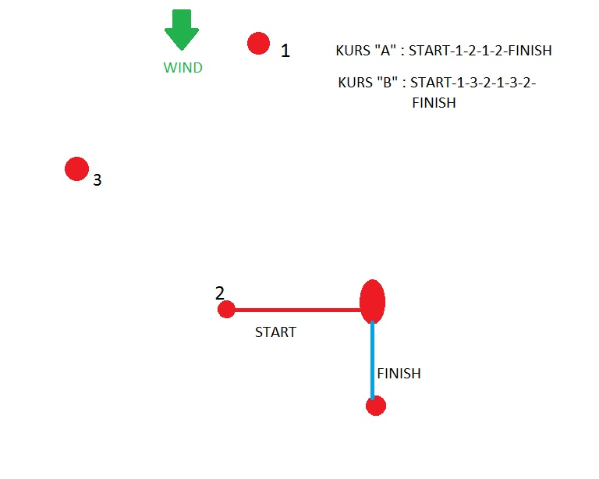

Aditionalinformations:

RankoAlujević : e-mail: jk.split@gmail.com
RokoMuštra: 095 8377188 / e-mail: treneri.jk@gmail.com

