NOTICE OF RACE
Open National Snipe – France 2018
10/May – 12/May 2018
Organized by la Société des Regates du Havre

1. RULES  The race will be managed according to :  1.1 the rules as defined in the Racing Rules of Sailing (2017-2020),  1.2 national authority prescriptions,  1.3 SCIRA Rules (general restrictions).  2. ADVERTISING  According to World Sailing Rule 20, amended by the French Sailing Association (FFV), racing boats might be expected to display advertising as chosen and provided by the organizing authority.  3. ELIGIBILITY AND ENTRY  3.1 The regatta is open to all Snipe Class Boats.  3.2 All athletes must respect following requirements to validate their registration :  - present their 2018 FFV « COMPETITION » licence (only for French competitors)  - a signed and completed parent consent for competitors under 18 years  - be a member of SCIRA (all),  - be a member of the AFS (only for french competitors).  4. FEES  Registration fee is 50 € per boats.  Pre-inscription is required before the 02nd may 2018. After this date, the organizing authority will have the right to increase the registration fee by 20%.  5. SCHEDULE  Date Time  Thursday 10 May 1100-1300 hrs 1300 hrs 1400 hrs 2030 hrs Registration Briefing Warning signal for the first race Opening diner  Friday 11 May 1100 hrs 1900 hrs 2030 hrs Warning signal for the first race General meeting AFV (french association) Diner (SRH)  Saturday 12 May 1100 hrs 1600 hrs 1730 hrs Warning signal for the first race No warning signal will be made after 1500 hrs Prize giving  6. SAILING INSTRUCTIONS  Sailing Instructions will be available at Check-in.  7. COURSES  7.1 Courses will be : trapezoid and/or olympic triangle.  7.2 The racing area will be located in the Bay of Le Havre.  8. RANKING  The minimum number of race to validate the championship is 3.  When 4 or more races have been completed, a boat’s series score will be the total of the race scores excluding the worst race. | 9. LIMITATION OF LIABILITY  The decision to participate into a race or to keep racing is the sole responsibility of the competitor. Therefore, by accepting to participate to the race or remain into a race, the competitor discharges the organizing authority of any legal or financial responsibility in case of damage to the boat or injury.  10. ADDITIONAL INFORMATION :  For more information, contact Société des Régates du Havre :  Quai Eric Tabarly, boulevard Clémenceau  76600 LE HAVRE  Phon : +33 2.35.42.41.21  Mail : secretariatvoile@lesregates.com  Parking :  Authorized for camping-cars on a parking near the Sailing-Club (ask the club for exact location). Free Parking for the cars parked behind the Club House.  Accommodations :  - IBIS offers a special fare to all FFV licensees – +33 2.35.22.29.29  - CRJS (Youth Sailing Sport Center) : 24,70€per room with bedsheets,and breakfast  +33 2.35.21.12.07  - Novotel : 20, cours la Fayette, 76600 LE HAVRE – +33 2.35.19.23.23  - Vent d’Ouest : 4, rue Caligny, 76600 LE HAVRE – +33 2.35.42.50.69  contact@ventdouest.fr  Ship chandlers, :  - Accastillage Diffusion : 120, rue Augustin normand, 76600 LE HAVRE  +33 2.35.43.43.62  - Le Havre Nautic : boulevard Clémenceau, 76600 LE HAVRE  +33 2.35.21.08.06  Le Havre Tourism Agency :  186, boulevard Clémenceau – BP 649 – 76059 LE HAVRE Cedex  Phone : +33 2.32.74.04.00  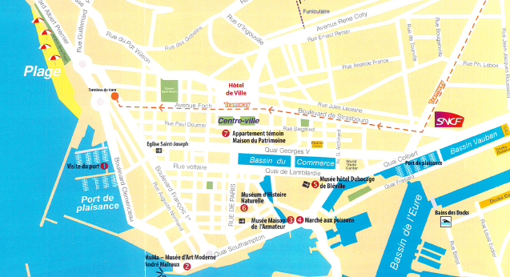

REGISTRATION’S FORM
Open National Snipe – France 2018
10/May – 12/May 2018

Sailing # : …………………………. Boat’s Name : ………………………..

 | Skipper | Crew
Last/First Name
License #
(only for French)
Phone #
Email

I hereby agree to apply the RRS 2017-2020 Sailing Rules, the Sailing Instructions as well as the SCIRA rules.
I agree that the organizers cannot be held responsible in case of injury or death, or in case of damage to the boat or the equipment. I have a valid insurance policy that can cover me and my 3rd party responsibilities.
I agree that SRH may possibly use for free any pictures of my crew or my boat, taken during the race or at the club house.

I pay the 50 € registration’s fee:

By credit card on the first day of the race

By check

Warning : cash won’t be accepted by SRH.
After the 02th of may 2018, SRH will have the right to increase registration feed by 20% (ie. 60€) in case of late registration.

Signed on ………………………….. in ……………………………………………..

Skipper’s signature :

Form to be sent to : Société des Régates du Havre
Quai Eric Tabarly, boulevard Clémenceau
76600 LE HAVRE
Phone : +33 2.35.42.41.21
Mail : secretariatvoile@lesregates.com

